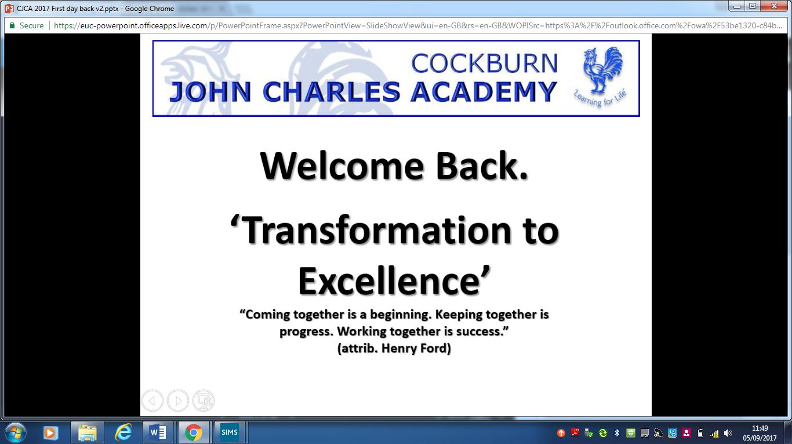

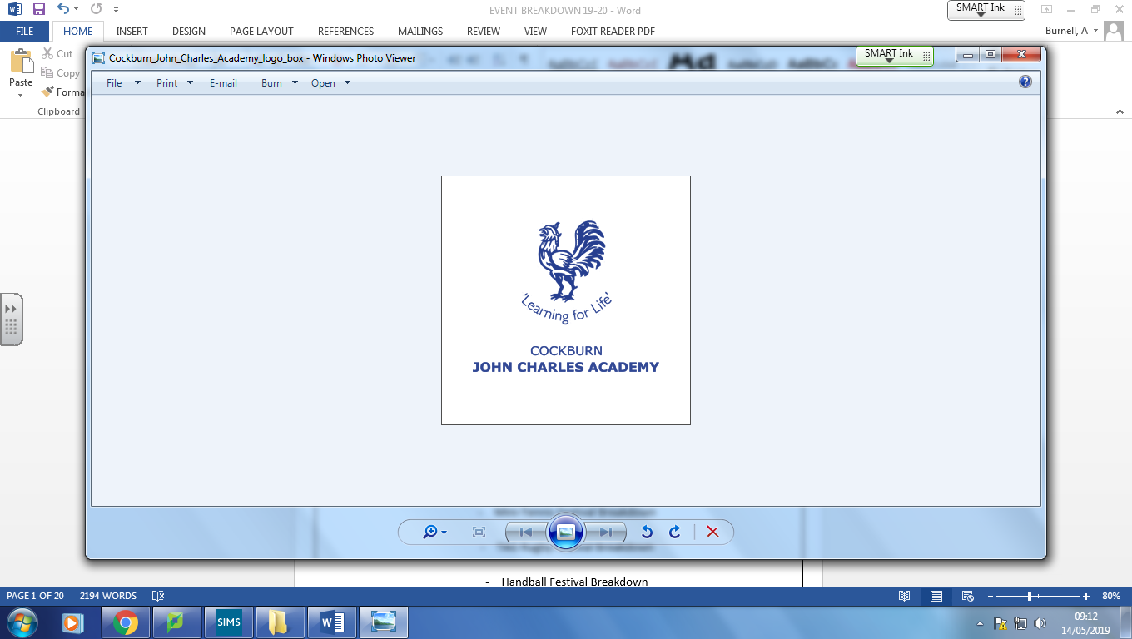

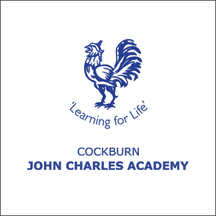

PRIMARY

PE PROGRAMME

**2021-22 HANDBOOK**



**Contents**

* 21/22 Calendar
* Sports Hall Athletics Event Breakdown
* BOUNCE - Trampoline Taster Breakdown
* Mini-Tennis Festival Breakdown
* TAG Rugby Festival Breakdown
* Handball Festival Breakdown
* Basketball Festival Breakdown
* Aqua Festival Breakdown
* 5 a-side Football Festival Breakdown
* - Rounders Festival Breakdown

- Primary Premiership

- Cockburn Cup Tickets

* Contact Details

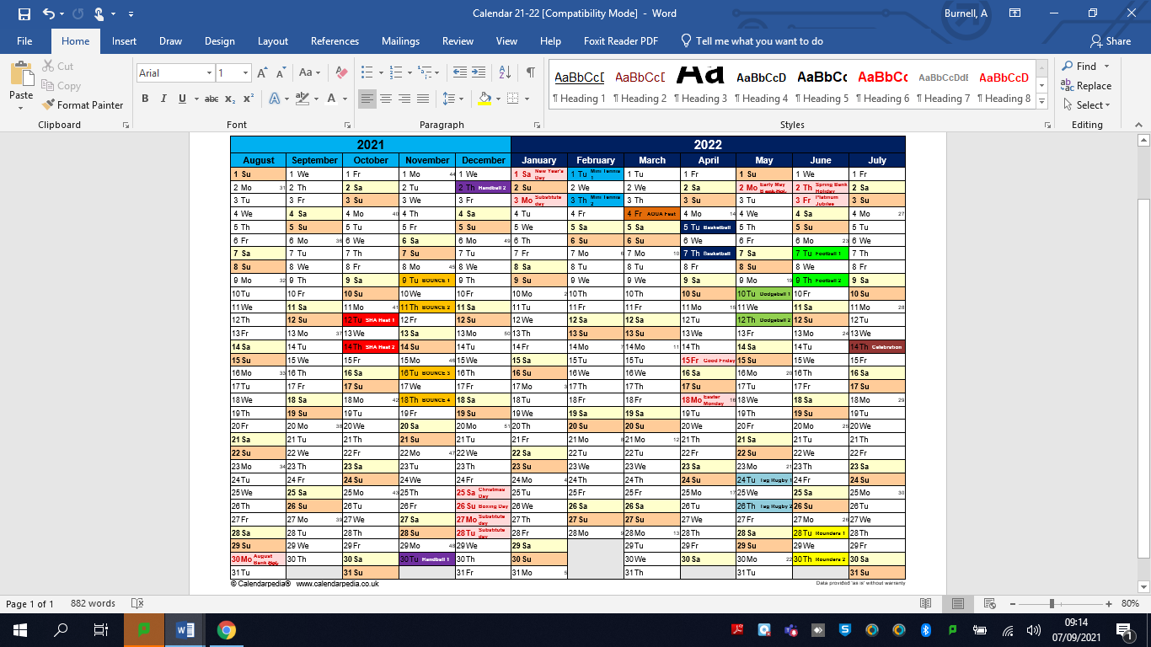



**Sports Hall Athletics**

We will run **TWO** Heats -   
**Heat 1:** 4 Schools (Tuesday 12st October)

**Heat 2:** 4 Schools (Thursday 14th |Octber)

@CJCA 3-5pm

The Sports Hall Athletics will be for **Lower & Upper KS2**  
One Lower KS2 Boys and Girls Team (Round 1) – Field Events   
One Upper KS2 Boys and Girls Team (Round 2) – Field Events  
One Combined Upper/Lower Boys and Girls Team – Track Events

**The Events**Track Events  
2 Boys & 2 Girls – 1+1 Lap Relays  
2 Boys & 2 Girls – 2+2 Lap Relays

These 4 Boys & 4 Girls could all run the;  
4x1 Lap Relay  
4x1 Lap Obstacle Relay  
4x1 Lap Hurdle Relay  
2 Boys & 2 Girls – PAARLAUF (Total 6 Laps of relay track, each lap taken in turn by each runner)

Field Events  
2 Boy & 2 Girl – Standing Long Jump  
2 Boy & 2 Girl – Standing Triple Jump  
2 Boy & 2 Girl – Vertical Jump  
2 Boy & 2 Girl – Chest Push  
2 Boy & 2 Girl – Foam Javelin



**BOUNCE – Trampoline Taster**

Each school will be given a 1-hour slot where you will bring 10 pupils (any year) for a Trampoline lesson @CJCA

2 Schools will attend each 1-hour slot  
  
Dates for the Trampoline Lessons  
Tuesday 9th November (15:00 – 16:00)  
Thursday 11th November (15:00 – 16:00)  
Tuesday 16th November (15:00 – 16:00)  
Thursday 18th November (15:00 – 16:00)

* Introduction on the Trampolines  
    
  - Develop Basic Jumps (Straight Jump/Half Twist/Tuck/Pike/Straddle/Seat Drop)
* Every pupil will aim to perform a minimum Four Bounce Routine.



**Handball**

@ CJCA

**League 1** – 4 Schools – (Tuesday 30th November)

**League 2** –4 Schools–(Thursday 2nd December)

Each school to bring 8 pupils from **KS1** to make their team.  
5 players per team on the pitch at one time.  
Rolling Substitutes.  
8 Minute Matches.

League format – all schools to play each other once

Win = 3 points Draw = 2 points Lose =1 point

**Rules**- Throw ball into the net to score a point  
- Non-contact sport  
- Cannot move with the ball  
- GK only in the penalty areas

 **Mini-Tennis**

**@JCCS Tennis Centre 3-5pm**

**League 1** – 4 Schools – (Tuesday 1st February)  
**League 2 –** 4 Schools (Thursday 3rd February)

Each school to bring 2 Boys, 2 Girls for a combined **Upper KS2** – 4 pupils per school.

Each Boy/Girl from each school to be ‘Seeded’ 1 and 2.

First to 10 points = Winner of the Match (Win = 3 Points, Participation = 1 Point)

Courts 1 and 2

Courts 3 and 4



**SPLASH – Aqua Festival**

**Friday 4th March**

4 Schools (9.30 – 12:00)

4 Schools (12:30 – 15:00)

@ JCCS Aquatics Centre

Schools to bring **Non-Swimmers, Beginner, Intermediate and Advanced Swimmers from KS2 (Yr3-6)**

Fun day of races, free play and water polo.

Breakdown of events to be sent closer to the date.



**Basketball**

**League 1** – Tuesday 5th April – 15:00 – 16:00 (4 schools)  
**League 2** – Thursday 7th April – 15:00 – 16:00 (4 schools)

**@ CJCA 3-4:15pm**

Each school to bring 8 pupils from **Upper KS2** to make their team.  
  
5 players per team on the pitch at one time.  
Rolling Substitutes.  
7 Minute Matches.

Schools to play 1 game against each other (3 Games)   
Win = 3 Points, Draw = 2 Points, Participation = 1 Point,



**Dodgeball**

**League 1** – Tuesday 10th May – (4 schools)

**League 2** – Thursday 12th May – (4 Schools)

**@CJCA 3.00-4.15pm**

Each school to bring 12 pupils to make a combined **KS1** team.  
10 players per team on the pitch at one time.  
Rolling Substitutes.  
7 Minute Matches.

All Out = 10 points then reset

Win = 3 Points, Draw = 2 Points, Participation = 1 Point



**TAG Rugby**

@CJCA

3-5pm

**League 1** – Tuesday 24th May (4 Schools)

**League 2** – Thursday 26th May (4 Schools)

Each school to bring 10 pupils from **Upper KS2** to make their team.  
7 Players on the pitch per team at one time.

Rolling Substitutes – Can make as many substitutes as you like.  
7 Minute Matches.

Win = 3 Points, Draw = 2 Points, Participation = 1 Point

 **5-a-side Football**

@JCCS Football Courts

3-5pm

**League 1** – Tuesday 7th June – (4 Schools)

**League 2** – Thursday 9th June – (4 Schools)

Each school to bring 8 pupils to make a combined **Lower KS2** team.  
5 players per team on the pitch at one time.  
Rolling Substitutes.

No head-high rule.  
12 Minute Matches (6 mins each way).

Win = 3 Points, Draw = 2 Points, Participation = 1 Point



**Rounders**

@CJCA

**League 1** – Tuesday 28th June (4 Schools) – 15:00 – 16:30pm

**League 2** – Thursday 30th June (4 Schools) – 15:00-16:30pm

Each school to bring 10 pupils from **Lower and Upper KS2** to compete.

1 League, all schools to play 1 game against each other.   
Win = 3 Points, Draw = 2 Points, Participation = 1 Point.

4th Base = rounder

2nd Base = ½ rounder

Hit behind = 1st base only

Miss the ball = must get to fourth for ½ rounder

1 Innings each



**Celebration Evening**

**Thursday 14th July @ CJCA – 3:15 -4:15pm**

Celebration evening to sign off the year – a chance to watch a school performance and share some photos from the years events.

10 pupils per school from various years.

Certificates awarded to all attending pupils.

Medal for Sports Person of the Year from each school.



**Primary Premiership**

This year all schools on the programme will take part in the CJCA Primary Premiership. Each event will gain teams points which will culminate in one school being crowned the overall champions. This will be presented at the celebration evening.

Scoring System

1st place = 10pts

2nd place = 8pts

3rd place = 6pts

4th place = 4pts

Failure to enter a team into an event = 0 points. If two teams are tied on equal points the winning team will be decided by who has won the most events. The champions will receive the Primary Premiership Trophy.



**Contact Details**

Adam Burnell – CJCA Primary Sports Coordinator  
Email: [burnella@cockburnjohncharles.org](mailto:burnella@cockburnjohncharles.org)

Phone Number: 0113 487 2800 Ext. 2134

Ben Clark – CJCA PE Head of Faculty  
Email: [Clarkb@cockburnjohncharles.org](mailto:Clarkb@cockburnjohncharles.org)

Phone Number: 0113 487 2800 Ext. 2134