Key Area: | Led by:
Assessment | Caroline Harvison

Context Statement:
The federation is made up of two schools: Windmill Primary (2 form entry) and Low Road Primary (1 form entry). Each class has a fully qualified class teacher and at least one other adult supporting learning. Teaching staff range from ECTs to UPS3+
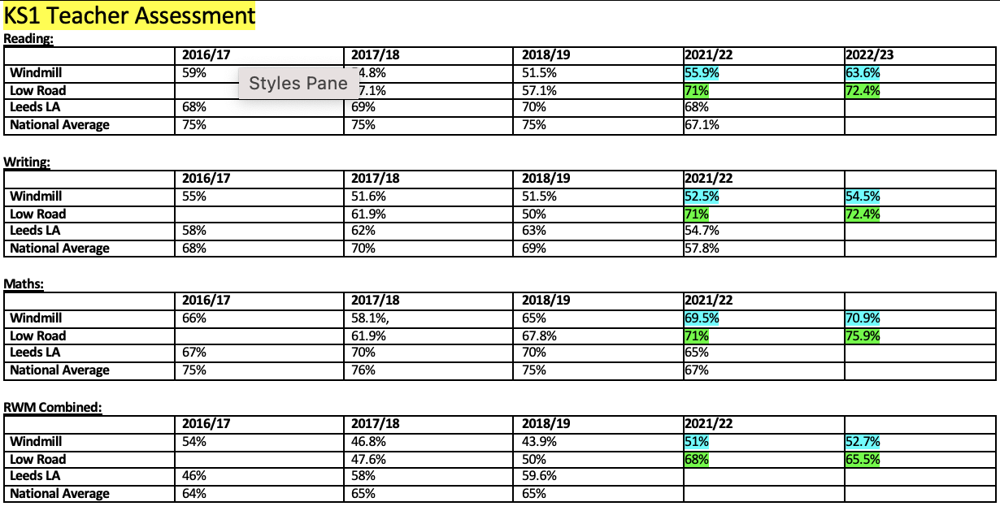

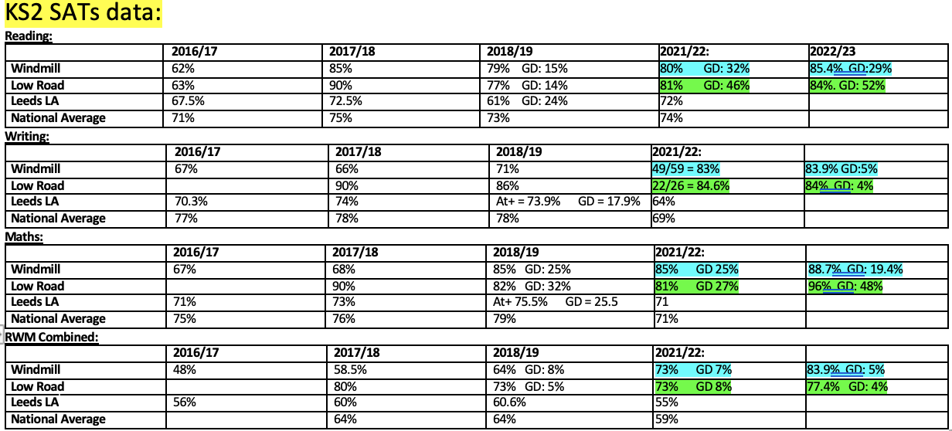

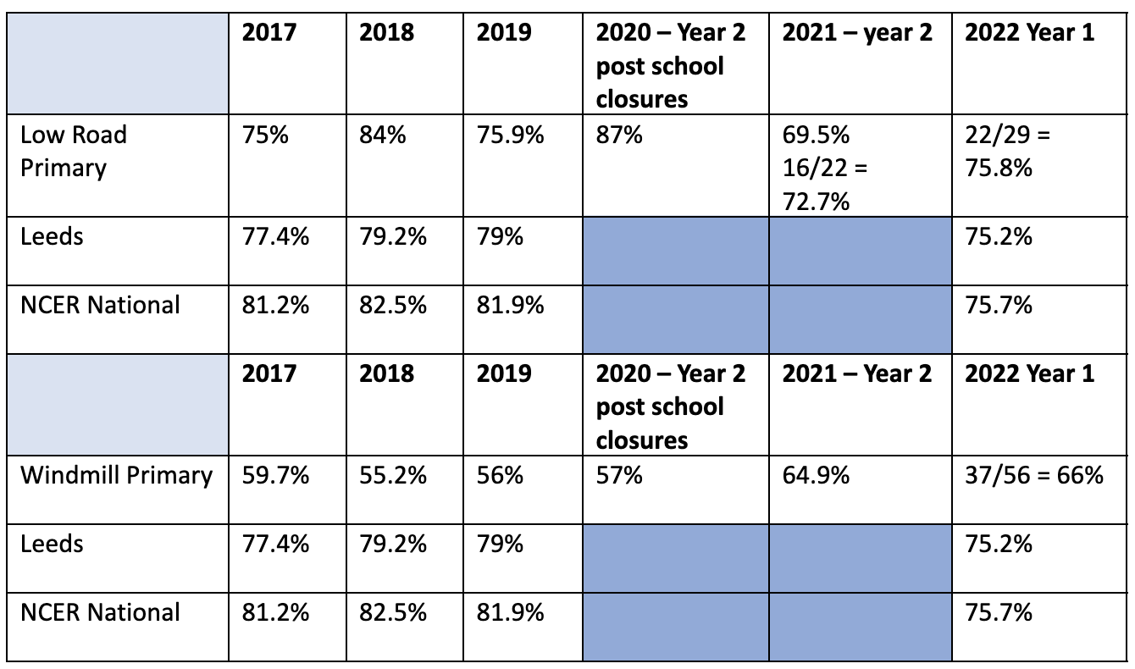

Overview of Key Priorities:
- All staff are confident in making attainment judgements including accurate assessments for SEND pupils
- Reception teachers use Arbor assessments in line with the federation
- Use Arbor to unpick data focusing on the key groups
- Use data to facilitate positive change regarding curriculum delivery

Proposed Outcomes
- All staff are confident and competent users of Arbor
- With support from SLT, staff quickly identify trends in data and use this to identify interventions as needed
- Learners work sampled matches attainment grade given
- Reception exit data cohesively links to KS1 entry data
- Data reported to LA/DFE is in-line or above National and LA figures

Priority Developments | Actions | Resources & Costs | Personnel | Timescale
Quality of Education | - On-going, formative assessments help staff take on a curriculum that is ambitious and designed to give all learners, particularly the most disadvantaged and those with special educational needs and/or disabilities (SEND) or high needs, the knowledge and cultural capital they need to succeed in life  - Assessment data helps subject leaders design an ambitious curriculum which meets the needs of all learners  - Teachers have good assessment knowledge of the subject/area they teach  - Subject leaders can clearly articulate their subject data and identify trends – this is exemplified through the ‘Subject on a Page’ overview  - Teachers and leaders use assessment well, for example to help learners embed and use knowledge fluently or to check understanding and inform teaching.  - Learners develop detailed knowledge and skills across the curriculum and, as a result, achieve well. Where relevant, this is reflected in results from national tests and examinations that meet government expectations, or in the qualifications obtained | Planning meeting time  Assessment time  CPD needs as Identified  SLT to partake in pupil progress meetings | SLT  Assessment Lead  Class teachers | On-going
Behaviour and Attitudes | - Build team ethos to ensure that current team and new/returning members of staff have a clear idea of school assessment policies and practice  - On-going pen portraits shared with staff identifying learners’ behaviour and attitudes | Meeting time | Business manager  SLT  Class teachers | On-going with constant review
Personal Development | - At each stage of the school, learners are provided assessment feedback which enables their future success  - Marking policy reflects the culture of learning within the classroom  - Pupils can articulate their own learning at any given point of the lesson/unit of work sharing successes as well as areas to develop | Marking policy development PPA  Pupil report feedback | SLT  Assessment Lead  Class teachers | On-going
Leadership and Management | - Assessment lead presents data clearly to a wide range of stakeholders as necessary  - Leaders understand the limitations of assessment and do not use it in a way that creates unnecessary burdens for staff or learners  - Leaders have a clear and ambitious vision for providing high-quality, inclusive education and training to all.  - Leaders engage with their staff and are aware and take account of the main pressures on them. They are realistic and constructive in the way assessment data is used and take into account their individual workloads  - At every stage of the assessment process, safeguarding policies are followed to ensure that no data is leaked leaving learners/the federation vulnerable.  - Provide ECTs/new staff/returning staff with bespoke training and continuous support in the monitoring and assessment systems used. | Management time allocated for assessment focus | SLT  Assessment Lead  Class teachers | On-going

