Autumn Term
Recurring themes / interests | Seasonal Change – Summer / Autumn  The World Around Me  Festivals & Celebrations  Me, myself and I
Cultural Capital opportunities linked to seasons, celebrations and festivals | Local Area Walk  Halloween  Bonfire Night  Remembrance Day  Diwali  Christmas
Parent Partnerships | Grandparents Stay and Play session   |   Supper & Sparkles Night |  |   Singing Around the Christmas Tree
Enrichment | Autumn Walk   |  |   Santa Visit
Story Time | 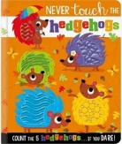  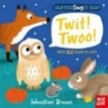  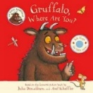    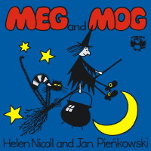  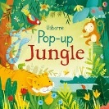    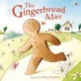        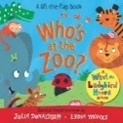  
On-going  Independence Focus | - I can separate from my main carer with ease  - I can feed myself with a spoon and I am beginning to use a fork with more accuracy  - I can drink from an open top cup  - I can put on simple clothing items such as a hat or slip on shoes / slippers  - I enjoy a range of mark making experiences on a large scale such as chunky chalks, crayons, paint, pencils and pens  - I enjoy listening and joining in with a range of rhymes, songs and stories and can repeat some word sand phrases from familiar stories  - I am beginning to link words and concepts together

Spring Term
Recurring themes / interests | Seasonal Change – Winter / Spring  The World Around Me  Festivals & Celebrations  Me, myself and I
Cultural Capital opportunities linked to seasons, celebrations and festivals | Local Area Walk  Shrove Tuesday  Chinese New Year  Easter  Mother’s Day
Parent Partnerships | Mother’s Day Stay and Play session   | Easter Stay and Play  
Enrichment | Spring Walk  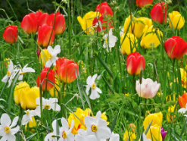 | Caterpillars / butterflies  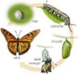
Story Time | 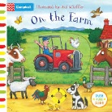  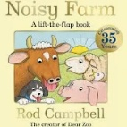  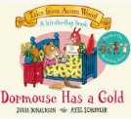  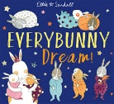  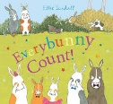  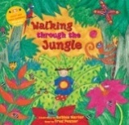    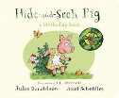  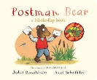  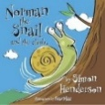  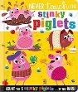  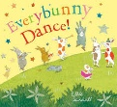
On-going  Independence Focus | - I can separate from my main carer with ease  - I can feed myself with a spoon and I am beginning to use a fork with more accuracy  - I can drink from an open top cup  - I can put on simple clothing items such as a hat or slip on shoes / slippers  - I enjoy a range of mark making experiences on a large scale such as chunky chalks, crayons, paint, pencils and pens  - I enjoy listening and joining in with a range of rhymes, songs and stories and can repeat some word sand phrases from familiar stories  - I am beginning to link words and concepts together

Summer Term
Recurring themes / interests | Seasonal Changes - Spring / Summer  The World Around Me  Festivals & Celebrations  Me, myself and I
Cultural Capital opportunities linked to seasons, celebrations and festivals | Local Area Walk  St. George’s Day  Father’s Day
Parent Partnerships |   Father’s Day Stay and Play Session
Enrichment | Duckling Eggs  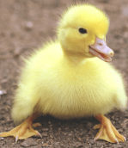 | 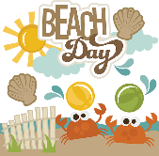  End of year event
Story Time | 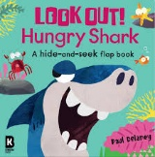    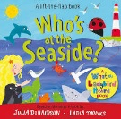      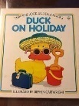  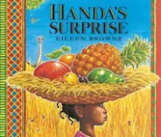  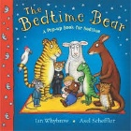  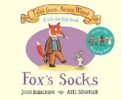  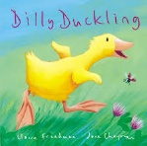  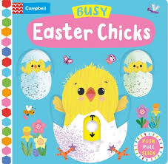
On-going  Independence Focus | - I can separate from my main carer with ease  - I can feed myself with a spoon and I am beginning to use a fork with more accuracy  - I can drink from an open top cup  - I can put on simple clothing items such as a hat or slip on shoes / slippers  - I enjoy a range of mark making experiences on a large scale such as chunky chalks, crayons, paint, pencils and pens  - I enjoy listening and joining in with a range of rhymes, songs and stories and can repeat some word sand phrases from familiar stories  - I am beginning to link words and concepts together

