Autumn Term
Recurring themes / interests | Seasonal Change – Summer / Autumn  The World Around Me  Festivals & Celebrations  Me, myself and I
Cultural Capital opportunities linked to seasons, celebrations and festivals | Local Area Walk  Halloween  Bonfire Night  Remembrance Day  Diwali  Christmas
Parent Partnerships | Grandparents Stay and Play session   |   Supper & Sparkles Night |  |   Singing Around the Christmas Tree
Enrichment | Autumn Walk   |  |   Santa Visit
Story Time |     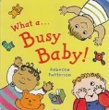    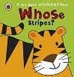  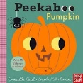  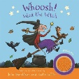  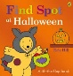  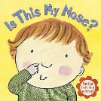      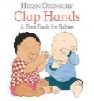  
On-going  Independence Focus | - I can separate from my main carer with help from a familiar adult  - I can point and gesture to objects I would like to use  - I enjoy a range of mark making experiences on a large scale such as chunky chalks, crayons, paint, pencils and pens  - I enjoy listening to a range of rhymes, songs and stories  - I enjoy joining in with games such as ‘peepo’ with an anticpacted action and response  - I am beginning to feed myself inpendently using a spoon or a fork  - I can help dress myself by putting arms into a coat

Spring Term
Recurring themes / interests | Seasonal Change – Winter / Spring  The World Around Me  Festivals & Celebrations  Me, myself and I
Cultural Capital opportunities linked to seasons, celebrations and festivals | Local Area Walk  Shrove Tuesday  Chinese New Year  Easter  Mother’s Day
Parent Partnerships | Mother’s Day Stay and Play session   | Easter Stay and Play  
Enrichment | Spring Walk  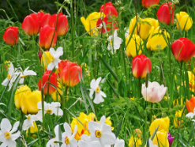 | Caterpillars / butterflies  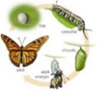
Story Time |   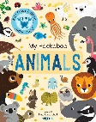  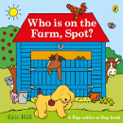  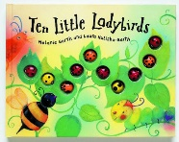    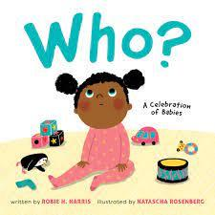    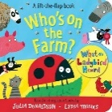  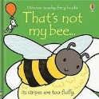  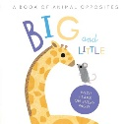    
On-going  Independence Focus | - I can separate from my main carer with help from a familiar adult  - I can point and gesture to objects I would like to use  - I enjoy a range of mark making experiences on a large scale such as chunky chalks, crayons, paint, pencils and pens  - I enjoy listening to a range of rhymes, songs and stories  - I enjoy joining in with games such as ‘peepo’ with an anticpacted action and response  - I am beginning to feed myself inpendently using a spoon or a fork  - I can help dress myself by putting arms into a coat

Summer Term
Recurring themes / interests | Seasonal Changes - Spring / Summer  The World Around Me  Festivals & Celebrations  Me, myself and I
Cultural Capital opportunities linked to seasons, celebrations and festivals | Local Area Walk  St. George’s Day  Father’s Day
Parent Partnerships |   Father’s Day Stay and Play Session
Enrichment | Duckling Eggs  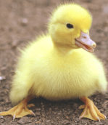 |   End of year event
Story Time | 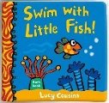  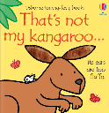  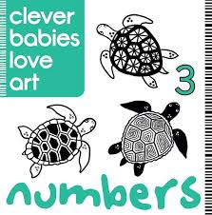  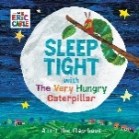  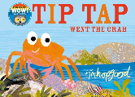  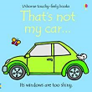  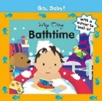  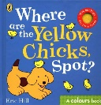  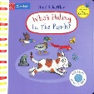  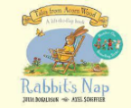  
On-going  Independence Focus | - I can separate from my main carer with help from a familiar adult  - I can point and gesture to objects I would like to use  - I enjoy a range of mark making experiences on a large scale such as chunky chalks, crayons, paint, pencils and pens  - I enjoy listening to a range of rhymes, songs and stories  - I enjoy joining in with games such as ‘peepo’ with an anticpacted action and response  - I am beginning to feed myself inpendently using a spoon or a fork  - I can help dress myself by putting arms into a coat

