Autumn Term
Recurring themes / interests | Seasonal Change – Summer / Autumn  The World Around Me  Festivals & Celebrations  Me, myself and I
Cultural Capital opportunities linked to seasons, celebrations and festivals | Local Area Walk  Halloween  Bonfire Night  Remembrance Day  Diwali  Christmas
Parent Partnerships | Grandparents Stay and Play session   |   Supper & Sparkles Night | 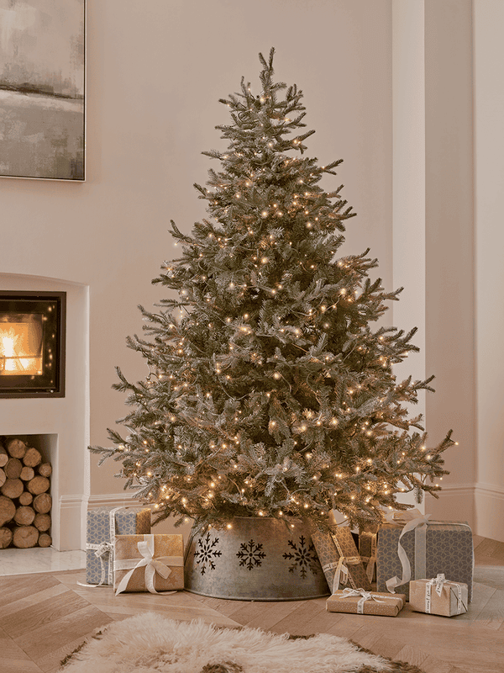  Singing Around the Christmas Tree
Enrichment | Autumn Walk   | Little Chefs  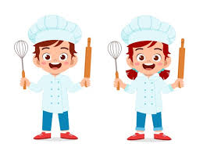 |   Santa Visit
On- going  Independence Focus | - I can use the toilet independently including wiping myself, washing and drying my hands and managing my own clothes.  - I can put on my own coat, hat and gloves and fasten my zip.  - I can use a knife and fork.  - I can open packaging on food items such a banana and orange peels, yogurt lids, crisp packets, straw wrappers.  - I can write some or all of my name.  - I know and can sing lots of songs and rhymes.  - I enjoy listening to longer stories and can talk about what happens.  - I can negotiate with my friends to solve arguments. For example, accepting that not everyone can be Spider-Man in the game, and suggesting other ideas.
Phonics | Environmental Sounds & Instrumental Sounds –  - Children will tune into the sounds that they can hear by playing games such as Mr. Bear’s keys and participate in ‘listening moments’ where they will have to use their listening ears really carefully.  At home, you can help by:  - Noticing sounds that you can hear all around you such as “I can hear a plane in the sky” or “I can hear the leaves crunching under my feet”, “I can hear the bubbles fizzing in my drink.”  - Listening to the stories such as ‘Peace at Last?’ https://www.youtube.com/watch?v=9U9y35kWBvM  - What sounds kept Mr Bear awake?  - What sounds can you hear around your own home and garden?  - Play guess that sound https://www.youtube.com/watch?v=gYn-dkLFQVU  - Listen to the sounds on YouTube. Can you guess which farm animal they belong to?
Story Time | 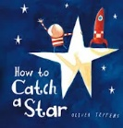  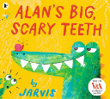  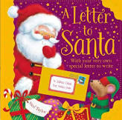  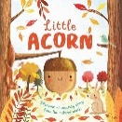  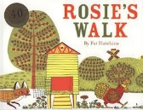  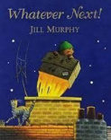  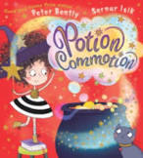  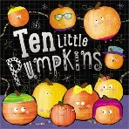  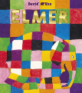  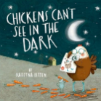  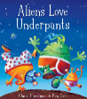  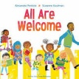  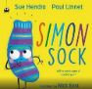
Maths | Children will be developing their understanding of number, shape, pattern and position through short daily directed sessions and throughout the day as they investigate through play. We spend lots of time ‘noticing’ and you will hear the children and adults regularly saying “I can see….” to comment on what they have noticed e.g “I can see two bikes outside!” “I can see stripes on my t-shirt”  At home, you can help by:  - Singing number rhymes until your child knows them really well. Please use the link for number rhyme videos  https://www.bbc.co.uk/teach/school-radio/articles/zn67kmn  - Spend lots of time noticing amounts of 1, 2 and 3 in pictures and in the environment and comment using the phrase “I can see….” E.g.  - “I can see 3 pigs in the picture” “I can see 1 letter from the postman” “I can see 2 cars on the drive”.  - Notice patterns on clothing and in the environment and talk about what you can see.

Spring Term
Recurring themes / interests | Seasonal Change – Winter / Spring  The World Around Me  Festivals & Celebrations  Me, myself and I
Cultural Capital opportunities linked to seasons, celebrations and festivals | Local Area Walk  Shrove Tuesday  Chinese New Year  Easter  Mother’s Day
Parent Partnerships | Mother’s Day Stay and Play session   |  | Easter Stay and Play session  
Enrichment | Spring Walk  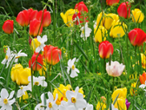 | Little Chefs |  | 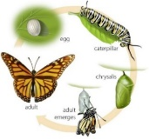  Caterpillars into Butterflies
On- going  Independence Focus | - I can use the toilet independently including wiping myself, washing and drying my hands and managing my own clothes.  - I can put on my own coat, hat and gloves and fasten my zip.  - I can use a knife and fork.  - I can open packaging on food items such a banana and orange peels, yogurt lids, crisp packets, straw wrappers.  - I can write some or all of my name.  - I know and can sing lots of songs and rhymes.  - I enjoy listening to longer stories and can talk about what happens.  - I can negotiate with my friends to solve arguments. For example, accepting that not everyone can be Spider-Man in the game, and suggesting other ideas.
Phonics | Body Percussion/Voice Sounds & Rhythm and Rhyme -  Children will will use their bodies to make music by clapping and tapping out repeated rhythms. They will develop a range of songs that they know really well and join in with the actions.  At home, you can help by:  - Singing action songs and rhymes such as the Grand Old Duke of York and Wind the Bobbin up – please see Spring rhymes list  - Reading stories such as ‘The Gruffalo’  - Can you find the rhyming words? e.g. wood & good, rumble & grumble, toes & nose  - Talk about what you can see in the pictures  - Can you use different voices for each of the characters?
Story Time | 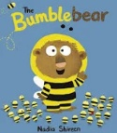  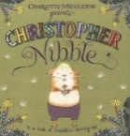  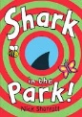  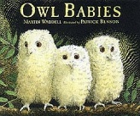  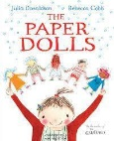  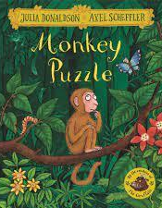  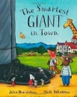  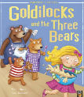  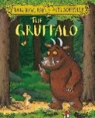  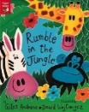  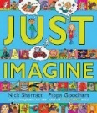  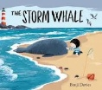
Maths | Children will be developing their understanding of number, shape, pattern and position through short daily directed sessions and throughout the day as they investigate through play. We spend lots of time ‘noticing’ and you will hear the children and adults regularly saying “I can see….” to comment on what they have noticed e.g “I can see two bikes outside!” “I can see stripes on my t-shirt”  At home, you can help by:  - Singing number rhymes until your child knows them really well. Please use the link for number rhyme videos  https://www.bbc.co.uk/teach/school-radio/articles/zn67kmn  - Spend lots of time noticing amounts of 1, 2 and 3 in pictures and in the environment and comment using the phrase “I can see….” E.g.  - “I can see 3 pigs in the picture” “I can see 1 letter from the postman” “I can see 2 cars on the drive”.  - Counting groups of objects  - Recognising numbers  - Compare objects by noticing their size, height, weight or length

Summer Term
Recurring themes / interests | Seasonal Change – Winter / Spring  The World Around Me  Festivals & Celebrations  Me, myself and I
Cultural Capital opportunities linked to seasons, celebrations and festivals | Local Area Walk  St. George’s Day  Father’s Day
Parent Partnerships |   Father’s Day Stay and Play Session |  | 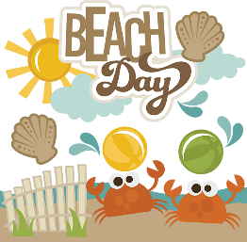
Enrichment | 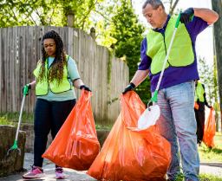  Litter Picking | Little Chefs |  | 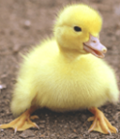  Duckling Eggs
On- going  Independence Focus | - I can use the toilet independently including wiping myself, washing and drying my hands and managing my own clothes.  - I can put on my own coat, hat and gloves and fasten my zip.  - I can use a knife and fork.  - I can open packaging on food items such a banana and orange peels, yogurt lids, crisp packets, straw wrappers.  - I can write some or all of my name.  - I know and can sing lots of songs and rhymes.  - I enjoy listening to longer stories and can talk about what happens.  - I can negotiate with my friends to solve arguments. For example, accepting that not everyone can be Spider-Man in the game, and suggesting other ideas.
Phonics | Oral Blending and Segmenting –  Children will will learn how to orally blend and segment spoken words such as c-a-t = cat and h-a-t = hat. This helps to develop the important skills they need for reading and writing in Reception.  At home, you can help by:  - Continuing to sing lots of songs and rhymes  - Continuing to read stories lots of wonderful stories.  - Play a simple game of ‘I – spy’ e.g I spy with my little eye a ‘d-o-g’ to see if your child can hear the word ‘dog’.
Story Time | 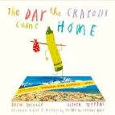  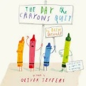  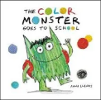  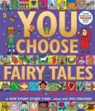  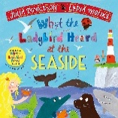  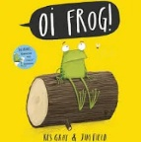  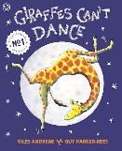  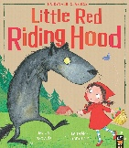  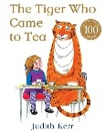  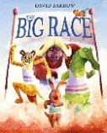  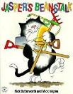  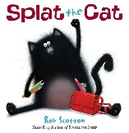
Maths | Children will be continue to develop their understanding of number, shape, pattern and position through short daily directed sessions and throughout the day as they investigate through play. We spend lots of time ‘noticing’ and you will hear the children and adults regularly saying “I can see….” to comment on what they have noticed e.g “I can see two bikes outside!” “I can see stripes on my t-shirt”  At home, you can help by:  - Singing number rhymes until your child knows them really well. Please use the link for number rhyme videos  https://www.bbc.co.uk/teach/school-radio/articles/zn67kmn  - Spend lots of time noticing amounts of 1, 2 and 3 in pictures and in the environment and comment using the phrase “I can see….” E.g.  - “I can see 3 pigs in the picture” “I can see 1 letter from the postman” “I can see 2 cars on the drive”.  - Counting groups of objects  - Recognising numbers  - Compare objects by noticing their size, height, weight or length

