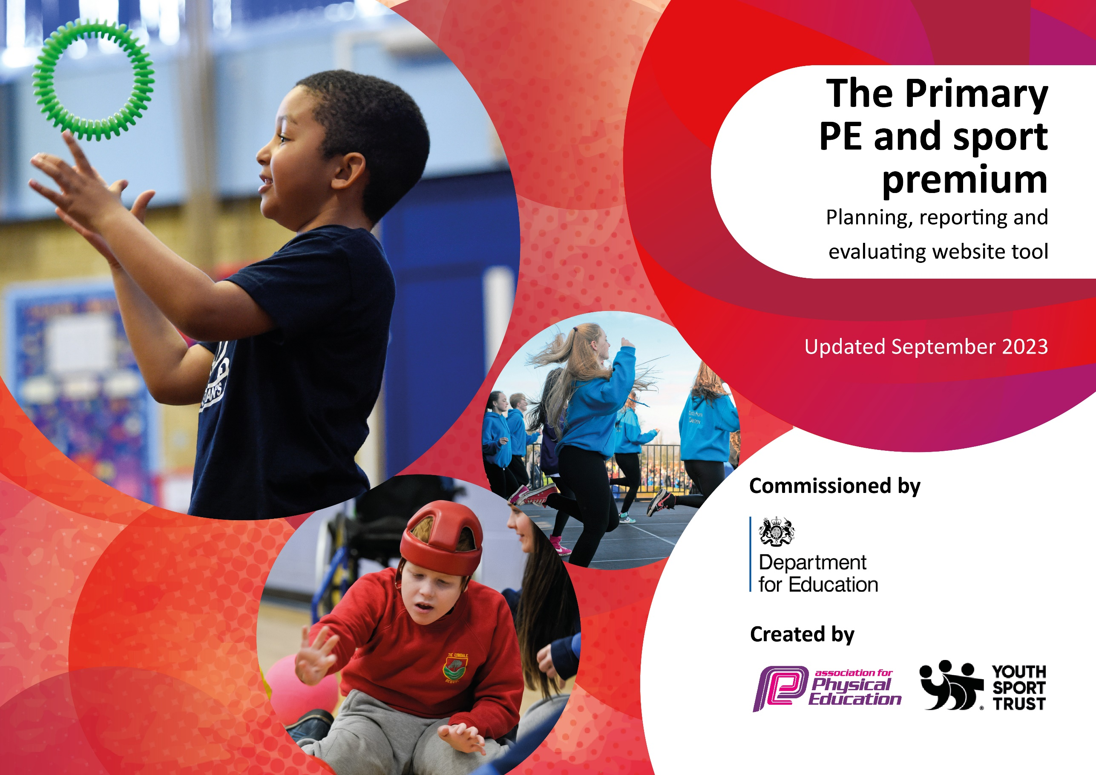

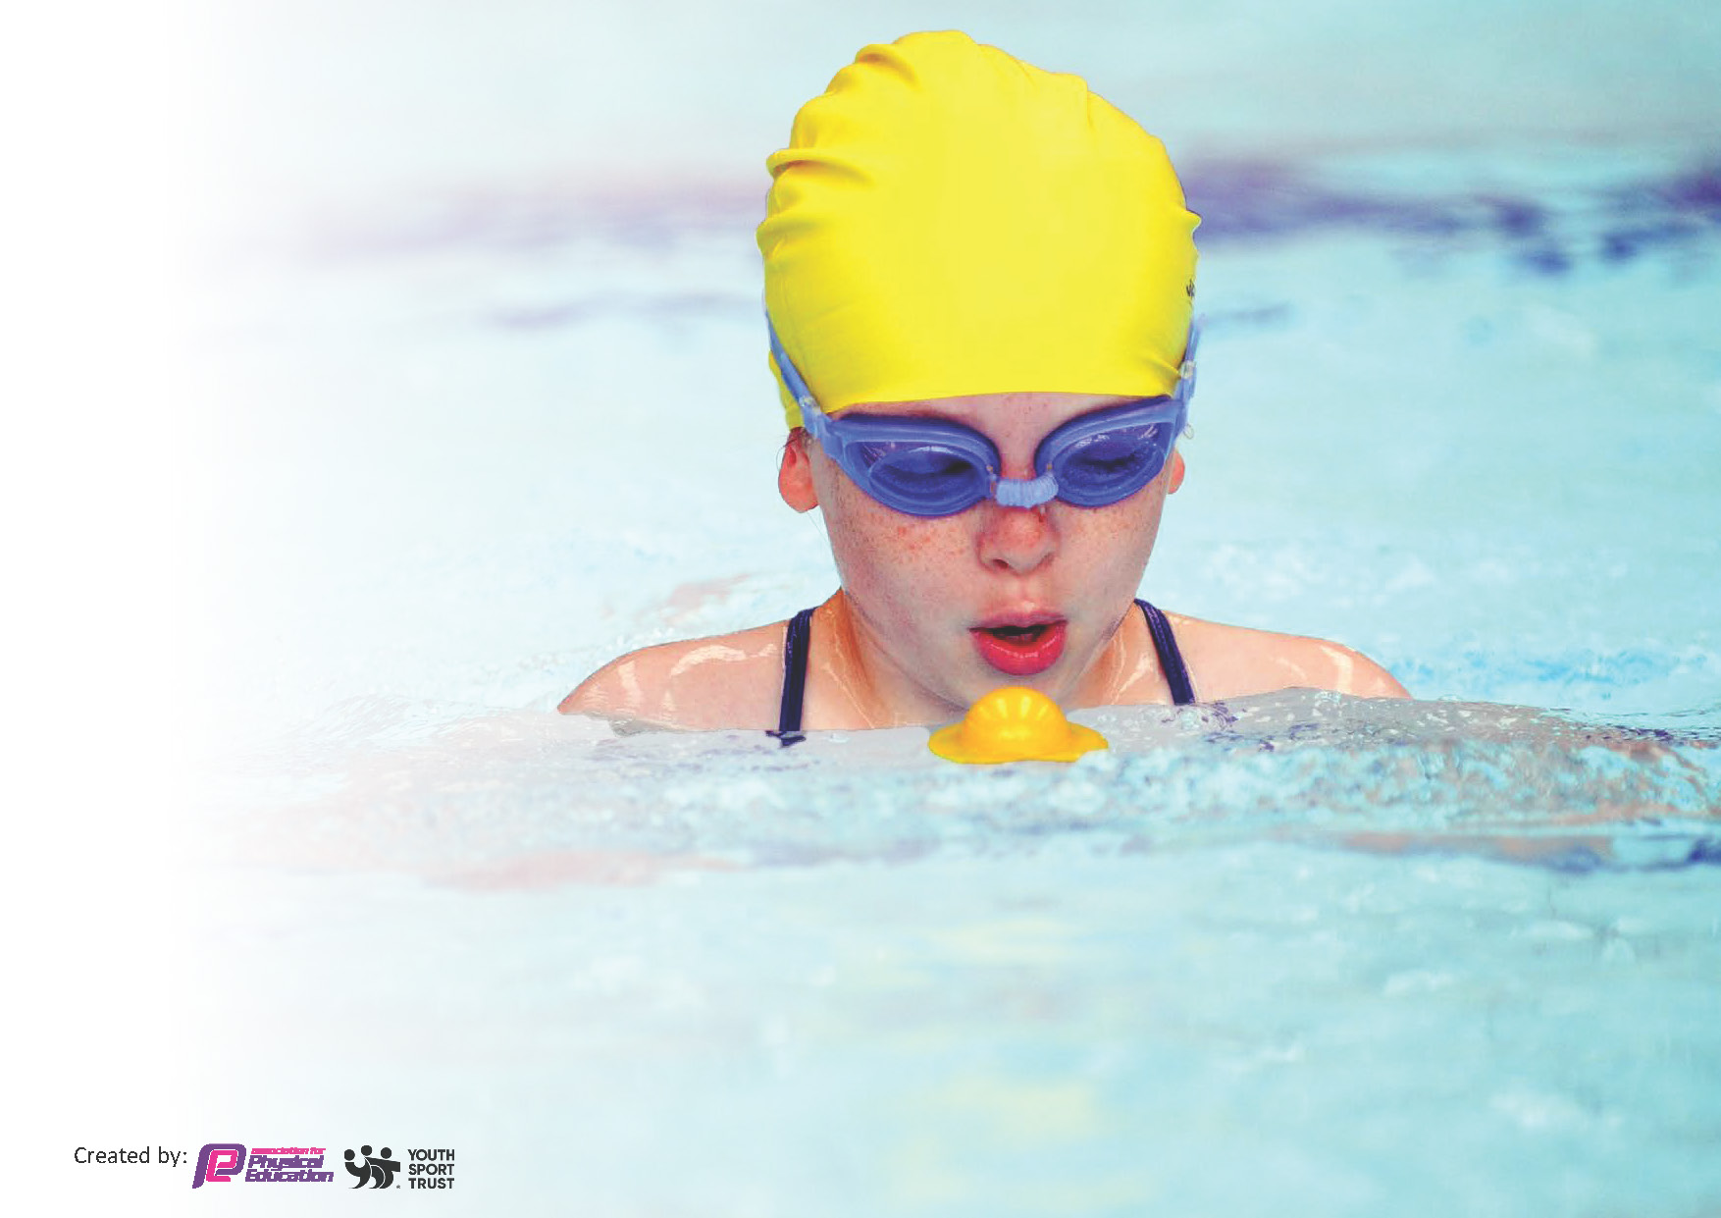
This template can be used for multiple purposes:
by:
- It enables schools to effectively plan their use of the Primary PE and sport premium
- It helps schools to meet the requirements (as set out in guidance) to publish information on their Primary PE and sport premium
- It will be an effective document to support Ofsted inspections enabling schools to evidence progress in Physical Education (PE) and evidence swimming attainment, which forms part of the PE National Curriculum. We would recommend schools consider
the Intent, Implementation and Impact of any spend, as examined within the Education Inspection Framework.

It is important that your grant is used effectively and based on school need.

Schools must use the funding to make additional and sustainable
improvements to the quality of the PE, School Sport and Physical Activity (PESSPA)
they offer. This means that you should use the Primary PE and sport premium to:

- Build capacity and capability within the school to ensure that improvements made now will benefit pupils joining the school in future years
- Develop or add to the PESSPA activities that your school already offers.

The Primary PE and sport premium should not be used to fund capital spend projects; the school’s core budget should fund these. Further detail on capital expenditure can be found in the updated Primary PE and sport premium guidance.

The Primary PE and sport premium guidance, outlines 5 key priorities that funding should be used towards. It is not

necessary that spending has to meet all the key priorities, you should select the priorities that you aim to use any funding towards.

Although completing this template is not a requirement for schools, schools are required to publish details of how they spend this funding. Schools must also outline what the impact this funding has had on pupils’ PE and sport participation and attainment and how any spending will be sustainable in the future. All funding must be spent by 31st July 2024.

The Department for Education has worked closely with the Association for Physical Education (afPE) and the Youth Sport Trust (YST) to develop this template and encourages schools to use it. This template is an effective way of meeting the reporting requirements of the Primary PE and sport premium.
Review of last year’s spend and key achievements (2022/2023)

We recommend you start by reflecting on the impact of current provision and reviewing your previous spend.

Activity/Action | Impact | Comments
Engagement in inter-school and external sporting competitions.  Engagement in external sporting competitions and opportunities.  HRF delivering curriculum and after-school sessions. | Children are more active and develop a passion for sports and competing in sports.  Children from a variety of age groups were given the opportunity to take part in a wide-range of sports competitions and activities.  Staff have been able to observe high-quality teaching of PE and sports. | Introduction of HRF has enabled more children to access sports.  Children are keen to take part in more clubs and competitions.

Key priorities and Planning
This planning template will allow schools to accurately plan their spending.

Action – what are you planning to do | Who does this action impact? | Key indicator to meet | Impacts and how sustainability will be achieved? | Cost linked to the action
Introduce lunchtime sport sessions/activities for pupils. | Lunchtime supervisors / teaching staff - as they need to lead the activity  Pupils – as they will take part & host it. | Key indicator 2 - The engagement of all pupils in regular physical activity – the Chief Medical Officer guidelines recommend that all children and young people aged 5 to 18 engage in at least 60 minutes of physical activity per day, of which 30 minutes should be in school.  Key indicator 4: Broader experience of a range of sports and activities offered to all pupils. | More pupils meeting their daily physical activity goal, more pupils encouraged to take part in PE and Sport Activities. | £1000 costs for additional coaches to support lunchtime sessions.

CPD for teachers.  CPD through teachers observing Hunslet Rugby Foundation (HRF) coach deliver sessions to their classes. | Primary generalist teachers.  Pupils – they take part in the PE lessons. | Key Indicator 1: Increased confidence, knowledge, and skills of all staff in teaching PE and sport.  Key indicator 2 - The engagement of all pupils in regular physical activity  Key indicator 5: Increased participation in competitive sport. | Primary teachers more confident to deliver effective PE supporting pupils to undertake extra activities inside and outside of school, including teaching water safety and swimming and as a result improved % of pupil’s attainment in PE. | Free – TW to deliver PDMs and provide  £3500 – Hunslet Rugby Foundation (part of the cost).
Continue to increase daily physical activity of our EYFS children, particularly outdoor learning. | Liaise with PE team and EYFS staff to ensure equipment bought is sufficient to raise physical activity and supports the EYFS PE learning outcomes/goals. | Key indicator 2 - The engagement of all pupils in regular physical activity  Key Indicator 4 – Broader experience of a range of sports and activities offered to all pupils. | Children are more active and make accelerated progress in the PE curriculum objectives – evidenced through Arbor.  EYFS children more consistently active on a daily basis. | £1000 for equipment for EYFS outside learning/play space.
After-school sports clubs – Delivered by teachers, HRF and Premier Sports. | Teachers.  External providers.  Pupils – they are involved. | Key indicator 2 – The engagement of all pupils in regular physical activity.  Key Indicator 4 – Broader experience of a range of sports and activities offered to all pupils.  Key indicator 5 – Increased participation in competitive sport. | More opportunities provided for a range of children from a variety of age groups.  Each club is different and children often vote for their chose of sport for the session. | £3500 – Partial cost from HRF
Purchasing sports equipment. | Teachers.  External providers.  Pupils. | Key indicator 2 – The engagement of all pupils in regular physical activity.  Key Indicator 3 – The profile of P.E and sport is raised across the school as a tool for whole school improvement.  Key Indicator 4 – Broader experience of a range of sports and activities offered to all pupils. | High-quality equipment available for all staff and external providers (if needed) to help deliver their P.E lessons and sporting activities. | £650
Visit of a current/former athlete. | Pupils. | Key Indicator 3 – The profile of P.E and sport is raised across the school as a tool for whole school improvement.  Key Indicator 4 – Broader experience of a range of sports and activities offered to all pupils. | Opportunity for pupils to learn from a professional athlete. Children given the chance to ask questions and take part in sporting activities. | £900
Sporting Trips and Events. | Teacher – leading the visits.  Pupils. | Key Indicator 3 – The profile of P.E and sport is raised across the school as a tool for whole school improvement.  Key Indicator 4 – Broader experience of a range of sports and activities offered to all pupils. | Children access sporting events and use this experience to take up new or more sports. | £4000  £4900 – Residential? Sporting activities we do at Lineham??
Bikeability | Pupils – taking part. | Key indicator 2 – The engagement of all pupils in regular physical activity.  Key Indicator 3 – The profile of P.E and sport is raised across the school as a tool for whole school improvement.  Key Indicator 4 – Broader experience of a range of sports and activities offered to all pupils. | Children learn to ride bicycles and learn road safety. This provides many children the chance to ride a bicycle and develop a life time engagement in cycling. | FREE
Data collection of how we can improve sports. | Pupils – completing the questionnaire. | Key indicator 2 – The engagement of all pupils in regular physical activity.  Key Indicator 3 – The profile of P.E and sport is raised across the school as a tool for whole school improvement. | Using this data and information to influence the sports, equipment and future opportunities provided for children. | Free
P.E Lead to observe PE lessons.  CPD Opportunities for PE lead. | P.E Lead  Staff | Key Indicator 1: Increased confidence, knowledge, and skills of all staff in teaching PE and sport. | Observations to inform feedback and improve P.E across the school for a more consistent and high-quality approach to teaching P.E.  P.E Lead to attend CPD events and use this experience to improve P.E across the school. | Free  £500
Purchasing kits for competitions and representation of the school. | Pupils – they are wearing them. | Key Indicator 3 – The profile of P.E and sport is raised across the school as a tool for whole school improvement. | Children to wear kits when competing and representing the school. | £1000

Key achievements 2023-2024
This template will be completed at the end of the academic year and will showcase the key achievements schools have made with their Primary PE and sport premium spending.

Activity/Action | Impact | Comments

Swimming Data
Meeting National Curriculum requirements for swimming and water safety.
Priority should always be given to ensuring that pupils can perform safe self-rescue even if they do not fully meet the first two requirements of the National Curriculum programme of study

Question | Stats: | Further context  Relative to local challenges
What percentage of your current Year 6 cohort can swim competently, confidently and proficiently over a distance of at least 25 metres? | 56% | Use this text box to give further context behind the percentage.  e.g., 30% - we are struggling to get pool space due to our local pool closing so we have had to use a much smaller local school pool. We have had to limit the number of pupils attending swimming lessons during one term which means some pupils have attended fewer swimming lessons than others.
What percentage of your current Year 6 cohort can use a range of strokes effectively [for example, front crawl, backstroke, and breaststroke]? | 45% | Use this text box to give further context behind the percentage.  e.g., Even though your pupils may swim in another year please report on their attainment on leaving primary school at the end of the summer term 2024

What percentage of your current Year 6 cohort are able to perform safe self-rescue in different water-based situations? | 32% | Use this text box to give further context behind the percentage.
If your schools swimming data is below national expectation, you can choose to use the Primary PE and sport premium to provide additional top-up sessions for those pupils that did not meet National Curriculum  requirements after the completion of core lessons. Have you done this? | No | On-going: will continue to look into this possibility however the timetable for the local swimming center is full (autumn 2023)
Have you provided CPD to improve the knowledge and confidence of staff to be able to teach swimming and water safety? | Yes – but needs updating | We have in the past and it is something we will look into again.

Signed off by:

Head Teacher: | Andy Gamble
Subject Leader or the individual responsible for the Primary PE and sport premium: | Tom Watters and Caroline Harvison
Governor: | (Name and Role)
Date:

