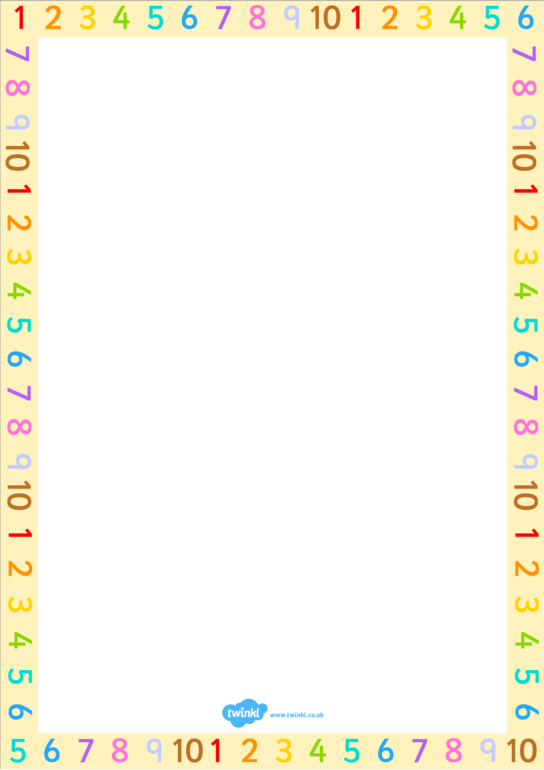

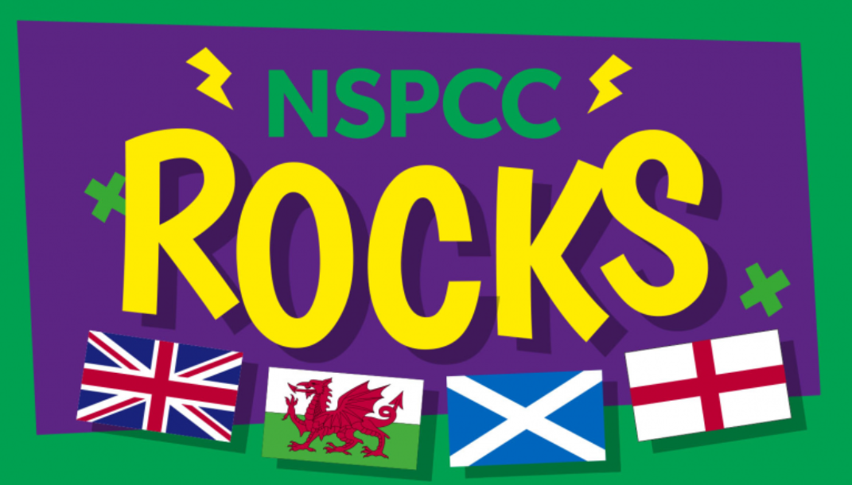


Maths Newsletter - Spring
Welcome back everyone! I hope that all of our families have had a fun-filled, relaxing Christmas and that our pupils are looking forward to their spring term maths lessons. For the first couple of week of this term, the maths learning per year group is as follows:
- EYFS: Numbers to 5
- Year 1: Place Value
- Year 2: Money
- Year 3, 4 and 5: Multiplication and Division
- Year 6: Ratio

“Mathematics is the music of reason.”

James Joseph Sylvester
Useful Maths information
To help your child with their maths at home away from a screen, try to estimate quantities when out and about:
- How many people are on the bus?
- How much will the shopping cost?
- How many people are at the park?
These are all great questions to inspire mathematical conversations. Have fun!

KS1 Maths Challenge
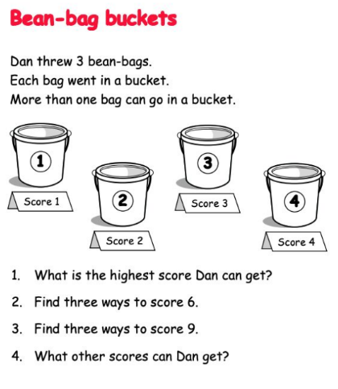

KS2 Maths Challenge
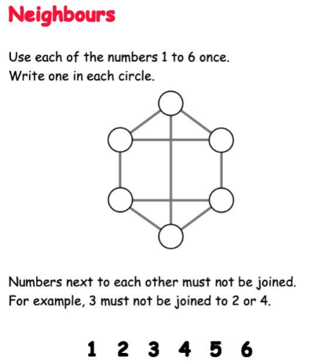

TTRS Competition for NSPCC Rocks
On 2rd February, pupils have the opportunity to take part in an exciting competition on TTRS, alongside raising awareness for the incredibly important charity, the NSPCC.
How does it work?
Learners will try to answer as many multiplication and division questions correctly as they can. The winning school and class will be based on the highest average number of correct answers per pupil.
Rules:
- Every correct answer that a student gives, in any game type, between the hours of 7:30 BST to 19:30 BST each day will contribute to their class and school score.
- There is a 60 minute limit playtime per player, per day.
- Each class has a minimum player count of
10. If fewer than 10 in the class play in the competition, their total will be divided by 10.

