Autumn Term
Recurring themes / interests | Seasonal Change – Summer / Autumn  The World Around Me  Festivals & Celebrations  Me, myself and I
Cultural Capital opportunities linked to seasons, celebrations and festivals | Local Area Walk  Halloween  Bonfire Night  Remembrance Day  Diwali  Christmas
Parent Partnerships | Grandparents Stay and Play session   |   Supper & Sparkles Night |  |   Singing Around the Christmas Tree
Enrichment |   Autumn Walk |  |   Santa Visit
Story Time | 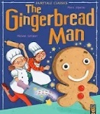    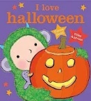  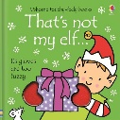  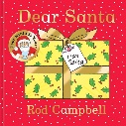    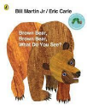  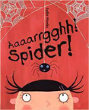  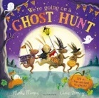  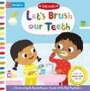      
On - going  Independence Focus | - I can use one handed tools and equipment such as pencils, scissors and paintbrushes.  - I can draw a person with a head and some facial features and give meanings to the pictures I draw  - I can eat independently with a spoon and fork.  - I can use the toilet and can pull my own pants up and down.  - I can talk about how I feel and why such as “I am sad because…” “I love it because…”  - I can listen to simple stories and understand what is happening, with the help of the pictures.  - I enjoy taking part in pretend play and cam act out simple scenarios I have experienced
Spring Term
Recurring themes / interests | Seasonal Change – Winter / Spring  The World Around Me  Festivals & Celebrations  Me, myself and I
Cultural Capital opportunities linked to seasons, celebrations and festivals | Local Area Walk  Shrove Tuesday  Chinese New Year  Easter  Mother’s Day
Parent Partnerships |   Mother’s Day Stay and Play session |  | Easter Stay and Play session  
Enrichment | 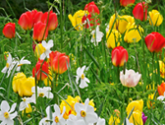  Spring Walk |  | Caterpillars into Butterflies  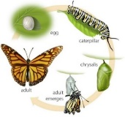
Story Time | 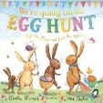  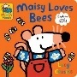      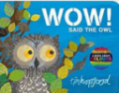  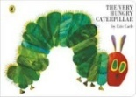      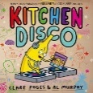      
On - going  Independence Focus | - I can use one handed tools and equipment such as pencils, scissors and paintbrushes.  - I can draw a person with a head and some facial features and give meanings to the pictures I draw  - I can eat independently with a spoon and fork.  - I can use the toilet and can pull my own pants up and down.  - I can talk about how I feel and why such as “I am sad because…” “I love it because…”  - I can listen to simple stories and understand what is happening, with the help of the pictures.  - I enjoy taking part in pretend play and cam act out simple scenarios I have experienced
Summer Term
Recurring themes / interests | Seasonal Changes - Spring / Summer  The World Around Me  Festivals & Celebrations  Me, myself and I
Cultural Capital opportunities linked to seasons, celebrations and festivals | Local Area Walk  St. George’s Day  Father’s Day
Parent Partnerships | Father’s Day Stay and Play Session  
Enrichment | 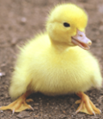  Duckling Eggs | End of Year Experience  
Story Time | 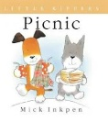  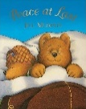  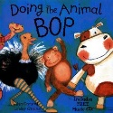  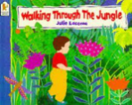  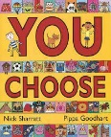  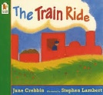  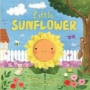      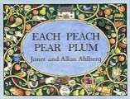  
On - going  Independence Focus | - I can use one handed tools and equipment such as pencils, scissors and paintbrushes.  - I can draw a person with a head and some facial features and give meanings to the pictures I draw  - I can eat independently with a spoon and fork.  - I can use the toilet and can pull my own pants up and down.  - I can talk about how I feel and why such as “I am sad because…” “I love it because…”  - I can listen to simple stories and understand what is happening, with the help of the pictures.  - I enjoy taking part in pretend play and cam act out simple scenarios I have experienced

