**Geography**

**Journeys – Trade**

- To understand that our food and clothes can come from all over the world

- To understand that each type of fruit grows in particular climatic conditions and in a particular season and that fruit may have to travel long distances to reach our fruit bowl.

- To understand that clothes can be produced fairly and sustainably, and to understand that unwanted clothing may be recycled and processed

- To investigate locally made and grown products available in our area, and to investigate locally imported products available in our area.

- To understand the perspectives of a range of people on geographical issues, and to understand that what people buy affects the lives of others.

**Mutual Respect & Tolerance – Learning about fair trade & how we can affect different parts of the world by purchasing goods.**

**Science**

**Animals including Humans:**

- To describe the changes as humans develop to old age. - To record data using scientific diagrams and labels.

- To identify scientific evidence that has been used to support or refute ideas or argument.

**Individual Liberty – learning how we develop into the human beings, we are today**

**Maths**

**Geometry: Position and Direction**

**Measurement: Converting Units**

See individual teacher’s Medium Term Plans for specific objectives and outcomes.

**Rule of law – Learning mathematical rules & how achieve our aims**

**Art**

**Sculpture:**

- Collect visual images of different sculptures - Use sketch books to record observations and use to review and revisit ideas - Annotate sketches to explain and elaborate - Design and make a wire sculpture - Show life-like quality and real-life proportions or, if more abstract, provoke different interpretations

**Individual Liberty – Expressing ourselves through Art**

**English**

**Genres to cover:**

- Narrative – Traditional Tales with a twist

- Poetry

See individual teacher’s Medium Term Plans for specific objectives and outcomes.

**Individual Liberty – Expressing ourselves & what we want to achieve in life through poetry.**

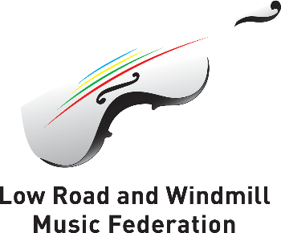

**Year 5 Overview**

***Summer 2***

**Trips and Visits**

**TBC**

**Computing**

**Recap of learning:**

- Producing & creating music using garage band app

- How to keep safe using the internet

- Designing, creating & debugging programmes

**Rule of Law – Learning online laws & keeping safe on the internet**

**Music**

In our final half term, we wind & brass will be rehearsing for their final show.

Individual Liberty – Expressing ourselves through music.

**PSHE**

**Careers, financial capability and economic wellbeing: Borrowing and earning money:**

– Learn that money can be borrowed but there are risks associated with this

- Learn about enterprise

- Develop understanding of what influences people’s decisions about career

**Rule of Law/Democracy – Learning how certain laws with finance & the risks money can bring.**

**PE**

**Swimming**

**Cricket:**

- To develop throwing accuracy and catching skills, including those specific to cricket e.g. wicket keeping

- To develop batting accuracy and directional batting.

- To develop overarm bowling technique and accuracy.

- To develop a variety of fielding techniques and to use them within a game.

- To develop long and short barriers and apply them to a game situation.

**Democracy – Learning to work as a team and agree on tactics to achieve a goal**

**Spanish**

**Areas to cover:**

- Do you have any pets?

- Consolidation of previous units  
**Mutual Respect & Tolerance – Learning about other cultures.**